SOCIAL SERVICES IMPROVEMENT PROJECT

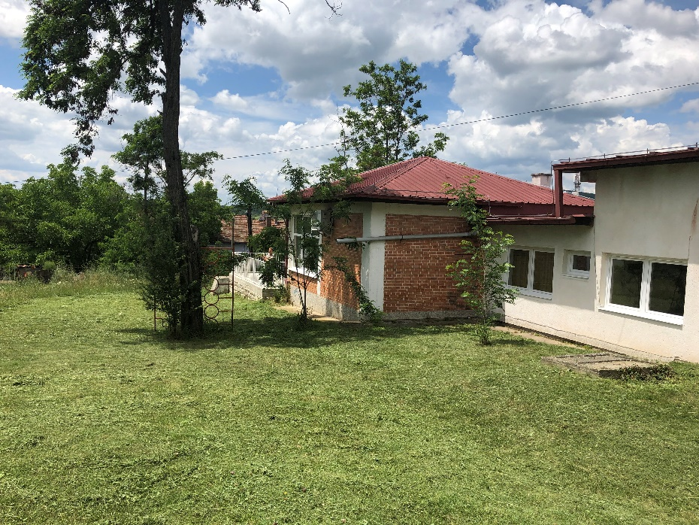

ENVIRONMENTAL AND SOCIAL MANAGEMENT PLAN (ESMP) CHECKLIST
Extension of existing kindergarten “Goce Delcev” in Municipality of Probistip
December 2019

Prepared by:
Slavjanka Pejchinovska-Andonova, MSc, Environmental Engineer
Environmental and Social (E&S) Specialist
Contents
1. Introduction 4
2. Project Description and planned activities 4
3. Environmental Category 5
4. Potential Environmental Impacts 5
5. Purpose of the Checklist ESMP 6
6. Application of the Checklist ESMP 6
7. Monitoring and reporting 7
ANNEX I: Checklist ESMP for the renovation/adaptation works 8
ANNEX II: Site Description 22

ABBREVIATIONS
E&S | Environmental and Social
ECEC | Early Childhood Education and Care services
ESMF | Environmental and Social Management Framework
ESMP | Environmental and Social Management Plan
ESS | Environmental and Social Standards
EU | European Union
H&S | Health and Safety
IBRD | International Bank for Reconstruction and Development
MLSP | Ministry of Labor and Social Policy
MSDS | Material Safety Data Sheets
OH&S | Occupational Health and Safety
PIU | Project Implementation Unit
PPE | Personal Protective Equipment
RM | Republic of Macedonia
SSIP | Social Services Implementation Project

Introduction
The conditions in the existing preschool institutions in the Republic of North Macedonia do not meet the requirements for proper childcare and are facing with lack of space for accommodation of children. For realization of a project for improving the access to Early Childhood Education and Care services (ECEC) and to social benefits and services, the Ministry of Labor and Social Policy of the Republic of North Macedonia intends to receive a loan from the International Bank for Reconstruction and Development (IBRD).
The aim of the loan is implementation of the Social Services Improvement Project (Project) which will provide renovation/adaptation of the existing kindergartens and schools, but also the construction of new ones in order to ensure more access to early childhood education.

Project Description and planned activities
Municipality of Probistip is an urban municipality in the eastern region of Republic of North Macedonia with a population of 14.558 inhabitants. Municipal administrative center is city of Probistip.
The total area of the parcel is 8022 m², the existing kindergarten takes up an area of 671 m² and with the reconstruction the area will increase for 487 m², with a total area of 1158 m². The construction percentage will be 14,44%.
The reconstruction of the kindergarten will be performed on the south-east side of the parcel.
The planned project activities will be performed in three phases:
- Preparatory activities:
  - Clearing up of the reconstruction site and transport of construction waste (911 m²) and soil waste (790 m²) to a landfill
  - Dislocation of existing installations on the parcel
- Reconstruction of the kindergarten:
  - New reinforced concrete structure
  - Installation of new wall, floor and roof insulation
  - Installation of new three glass layer PVC windows and doors
  - New roof and rain gutters
- Operational phase:
- Commissioning of the kindergarten and activities related to regular operation of the kindergarten
The existing kindergarten uses two oil boilers for heating, but they are in a very bad condition and are very inefficient, so the reconstructed kindergarten will change its heating system and will use a more efficient pellet boiler with Qk = 250 KW and a pellet reservoir of 550 l. The kindergarten is already connected to the existing water supply and sewage infrastructure.
The maximum capacity of this kindergarten in the existing facility is 125 children in six educational groups. With implementation of this project, it will be provide additional accommodation of 70 children divided into following groups:
- homogeneous group - up to two years of 10 to 12 children (2 groups);
- educational group over two to four years of 18 to 20 children (1 group); and
- educational group over four to six years of 20 to 25 children (1 group).

Environmental Category
For addressing the potential environmental and social concerns of the Project the Environmental and Social Management Framework (ESMF) was prepared (as part of the “Improving social services” of the MLSP) in May 2018, by the Environmental and Social (E&S) Specialist which is in accordance with the requirements of the World Bank. The ESMF represents a tool for Assessment and Management of Environmental and Social Standards, which allows conducting of an in-depth analysis of the environmental and social issues.
Preliminary screening according to the World Bank risk classification identifies 2 risk categories of the sub-projects: with substantial risk or with moderate risk for which different due diligence instruments need to be prepared.
“Category B+” / projects with substantial risk requires site-specific ESMPs, which should include site-specific information with mitigation measures and monitoring plan.
“Category B” /projects with moderate risk sub - projects require preparation of the ESMP Checklist by the sub-project proponent that identify potential environmental improvement opportunities and recommend measures for the prevention, minimization and mitigation of adverse environmental and social impacts.
Sub project environmental screening table for SSIP Project
Types project activities | Environmental Assessment due diligence documents required | Applicable to:
1 | Initial Limited Environmental and Social Impact Assessment (LESIA) | New construction of a kindergarten (placement of new infrastructure, expected major/moderate environmental and social impacts, usage of hazardous materials, etc.)
2 | ESMP Checklist | Renovation/adaptation of the existing kindergarten facilities/ school buildings (improving the condition of the functional characteristics of the facility: replacement of windows, demolition of walls, changing of floor, putting isolation, improving the façade, improving the way of heating/cooling, etc.)

Potential Environmental Impacts
From the implementation of the SSIP potential risks and impacts are expected to be temporary and/or reversible; low in magnitude and site-specific. These impacts are related to:
- dust nuisance and gaseous emissions,
- potential pollution of soil and water resources (accidental spillage of machine oil, lubricants, fuel, etc…),
- generation of different types of hazardous and non - hazardous waste,
- asbestos generation,
- noise,
- possible temporary disruption of current traffic circulation,
- traffic safety.

Purpose of the Checklist ESMP
ESMP checklist will be used for the projects for renovation/adaptation of the existing kindergartens or schools premises for kindergarten purposes. In compliance with the World Bank safeguard requirements the checklist consists of three phases:
1) General identification and scoping phase, in which the renovation/adaptation of the kindergarten works that need to be carried out. At this stage according to the carried out works the potential negative/adverse impacts can be identified. The parts 1, 2 and 3 are drafted. The second part of the ESMP Checklist contains all of the typical activities and their relation with the typical environmental issues and appropriate mitigation measures.
2) The second phase contains the project specifications and the bill of quantities for the renovation/adaptation works and other services related to the subproject. In this phase, the tender and the award of the works contracts and also the obligations defined in the Contract of the Contractor are defined. At the tendering stage the ESMP Checklist needs to be publicly submitted.
3) During the implementation phase the Contractor implements ESMP Checklists mitigation and monitoring, while environmental compliance (with ESMP Checklist and environmental and health and safety (H&S) regulation) and other qualitative criteria are implemented on the respective site and application checked/supervised by the site supervisor, which include the site supervisory engineer or supervisor of the project.
During the renovation/adaptation phase of the project the mitigation and monitoring measures prescribed in the ESMP Checklists are implemented by the Contractor. The compliance of the environmental and qualitative criteria are examined by the supervisor i.e. engineer. The Contractor’s environmental compliance is proven through the monitoring and mitigation plan.
Practical application of the ESMP Checklist will include the achievement of Part I for having and documenting all relevant site specifics. In the second part, the activities to be carried will be checked according to the envisaged activity type and in the third part the monitoring parameters (Part 3) will be identified and applied according to activities presented in Part 2.
The whole ESMP Checklist filled in table for each of the type of work will be attached as integral part of bidding and work contracts and as analogue with all technical and commercial conditions which should be signed by the contracting parties.

Application of the Checklist ESMP
After completing the Environmental and Social Screening Checklist by the ESS Specialist it has been determined that, this project is classified as a “project with moderate risk”.
The ESMP Checklist is used for projects that includes only renovation/adaptation of the existing kindergartens or premises for kindergarten purposes (improving the condition of the kindergartens – removing of asbestos where needed, etc.).
The Checklist is divided in 4 parts:
- Introduction in which the project type is described, definition of the environmental category, and Checklist ESMP concept explained;
- Part 1 - Descriptive part of the project (“site passport”) location, project description, legislation and public consultation process is given;
- Part 2 - Analysis of the environmental and social aspects for every activity through yes/no questions followed by mitigation measures for each activity;
- Part 3 - Plan for monitoring of the activities during the 3 phases: preparation, renovation/adaptation and operation.
The ESMP Checklist for the renovation/adaptation works contains the environmental impacts and suitable mitigation measures in order to reduce to minimum the impacts on the environment (air, noise and water pollution). It also offers management practice for hazardous and non-hazardous wastes and measures for control of the discharged medium at the construction site. In the ESMP Checklist there are steps that need to be done if at the renovation site there are objects of significance i.e. historic buildings.

Monitoring and reporting
Monitoring of the proposed mitigation measures for environmental protection and OH&S will be performed by site supervisor or responsible person appointed by the Municipality including environmental and civil engineer that will supervise proper implementation of project activities (according the monitoring plan (part 3).
In the table part of the document clear mitigation and monitoring measures are explained in detail with the purpose to be included in the works contracts.
The mitigation measures for the project activities include the use of Personal Protective Equipment (PPE) by workers on site, air pollution prevention, amount of water used and discharged at the site, wastewater treatment, maintenance of the proper sanitary facilities for workers, waste collection of separate types (soil, metals, plastic, hazardous waste, e.g. paint residues, asbestos, motor hydraulic oil), amounts of waste, proper organization of disposal pathways and facilities, or reuse and recycling wherever possible. In addition to Part 3, the site supervisors should check whether the contractor complies with the mitigation measures in Part 2.
If there are non-compliances in the monitoring report penalties previously introduced in the contract will be issued. For extreme cases, a termination of the contract shall be contractually tied in.
Is very important for providing continuous performance of the project activities and successful completion of overall project trough good communication between all involved stakeholders (Contractor, Supervisor, municipal staff, PIU from MLSP and other relevant persons from the Municipality of Probistip).

ANNEX I: Checklist ESMP for the renovation/adaptation works
PART 1: INSTITUTIONAL & ADMINISTRATIVE
Country | Republic of North Macedonia
Sub-Project title | Social safeguard Improvement Project, Republic of North Macedonia
Scope of sub-project and particular activities | Extension of the existing kindergarten “Goce Delcev” in Municipality of Probistip
Institutional arrangements  (Name and contacts) | WB (Project Team Leader) | Project Management |  | Local Counterpart and/or Recipient
 | To be decided  Tel:  email: | To be decided  Tel:  email: |  | To be decided  Tel:  email:
Implementation arrangements  (Name and contacts) | Safeguard Supervision | Local Counterpart Supervision |  | Local Inspectorate Supervision | Contactor
 | To be decided  Tel:  email: | To be decided  Tel:  email: |  | To be decided  Tel:  email: | To be decided  Tel:  email:
Implementation arrangements  (Name and contacts) | Supervision** (Upon completion of the procedure, the name and  contact of the Supervising Engineer will be added to the fields  below).
 | Will be determined after completing the public procurement procedures for the sub-project need.
SITE DESCRIPTION
Name of site | The already existing kindergarten “Goce Delcev” is located in Probistip, on “Goce Delcev” bb street, on the CP 1055/1 and CP 1055/3.
Describe site location (geographic description) | The extension of the existing kindergarten will be performed in Municipality of Probistip, in City of Probistip. The kindergarten is surrounded by “Goce Delcev” street to the west, residential houses to the north and south and green fields to the east. Elementary school “Brakja Miladinovci” is located 200 meters to the north, High School “Naum Naumovski – Borche” is located 150 meters to the north. The Probistip Municipality building is located 200 meters to the west, while the House of Culture and the City park are located 300 meters to the west. |  | Annex 1: Site information (figure from the site) [x]Y [] N
Who owns the land? | Republic of North Macedonia
Geographic description | Country: RNM  Region: East planning region  Municipality: Probistip  Settlement: Probistip
LEGISLATION
Identify national &local legislation & permits that apply to sub-project activity(s) | - Law on Environment (Official Gazette No.53/05,81/05,24/07,159/08, 83/2009, 124/2010, 51/2011, 123/12, 93/13, 163/13, 42/14, 44/15 129/15, 192/15, 39/16, 99/18);  - Law on Waters (Official Gazette No. 87/08, 6 / 09, 161/09, 83/10, 51/11, 44/12, 163/13);  - Law on Waste (Official Gazette No. 68/04, 71/04, 107/07, 102/08, 134/08, 124/10 and 51/11, 123/12, 147/13, 163/13, 146/15, 192/15);  - List of Waste Types (Official Gazette No. 100/05);  - Law on Nature Protection (Official Gazette No. 67/06, 16/06, 84/07, 59/12, 13/13, 163/13, 146/15);  - Law on Noise Protection (“ Official Gazette No. 79/07, 124/10, 47/11, 163/13, 146/15);  - Law on Chemicals (Official Gazette of the Republic of Macedonia No. 145/10, 53/11, 164/13, 116/15 and 149/15);  - Law on Ambient Air Quality (Official Gazette No. 67/04 with amendments Nos. 92/07, 35/10, 47/11, 59/12, 163/13, 10/15, 146/15);  - Law on Protection of Cultural Heritage (Official Gazette No. 20/04, 115/07, 18/11, 148/11, 23/13, 137/13, 164/13, 38/14, 44/14);  - Law on Occupational Health and Safety (Official Gazette No. 92/07, 98/10, 93/11, 136/11, 60/12, 23/13, 25/13, 164/13);  - Law for Health Protection (Official Gazette No. 07/07, 44/11, 145/12, 87/13);  - Law on Access to Public Information (Official Gazette of RM no. 13/06, 86/08, 06/10, 42/14, 148/15, 55/16);  - Law on Traffic Safety (Official Gazette of RM no. 169/15, 55/16);  - Law on the Protection of Children (Official Gazette of the RM ”No. 23/13, 12/14, 44/14, 144/14, 10/15, 25/15, 150/15, 192/15, 27/16, 163/17, 21/18 and 198 /18);  - Rulebook on standards and norms for performing activities of child care institutions (Official Gazette of the RM No. 28/14, 40/14, 136/14, 71/15 and 170/16).
PUBLIC CONSULTATION
Identify when / where the public consultation process took place and what were the remarks from the consulted stakeholders | The draft Environmental and Social Management Plan (ESMP) Checklist (for the projects with moderate risk) will be available for the public for 14 days on web site of the Municipality of Probistip and the web site of the MLSP PIU. All relevant comments and suggestions received by the stakeholders will be included into the final ESMP checklist and will be submitted to the PIU for the approval by the MLSP Environmental Expert and World Bank Specialist. Approved Final version of ESMP Checklist should be included in the Grant Agreement with the proponent and respective bidding documents and construction contracts.
INSTITUTIONAL CAPACITY BUILDING
Will there be any capacity building? | [x] N or []Y

PART 2: ENVIRONMENTAL /SOCIAL SCREENING
Will the site activity include/involve any of the following potential issues/risks: | Activity | Status | Additional references
 | A. General conditions |  | See Section A
 | B. General renovation/adaptation activities  - Site specific vehicular traffic  - Increase in dust and noise from renovation/adaptation activities  - Generation of waste  - Transport of materials and waste | [x] Yes [ ] No | If “Yes” , See Section A, B below
 | C. Are the renovation/adaptation activities taking place near water bodies such as rivers, lakes, etc.?  - Increase in sediments loads in water bodies  - Changes of water flow  - Pollution of water due to temporary waste disposal or spill leakages | [] Yes [x ] No | If “Yes”, See Section A, B, C below
 | D. Vicinity of any historical building/s or areas  - Risk of damage to known/unknown historical buildings/areas | [ ] Yes [x] No | If “Yes”, See Section A, B, D below
 | E. Traffic and Pedestrian Safety  - Site specific vehicular traffic  - Site is in a populated area | [x] Yes [ ] No | If “Yes”, See Section A, B, E below
 | F. Usage of hazardous or toxic materials and generation of hazardous waste  - Removal and disposal of toxic and/or hazardous waste during the renovation activities  - Storage of machine oils and lubricants | [] Yes [x] No | If “Yes”, See Section A, B, F below
 | G. Generation of asbestos waste during the demolition of existing kindergarten parts (roof, walls, floor) | [ ] Yes [x] No | If “Yes”, See Section A, B, G below
 | H. Replacement/Removal of mercury lights | [ ] Yes [x] No | If “Yes”, See Section A, B, H below
 | I. Dismantling of underground installations | [] Yes [x ] No | If “Yes”, See Section A, B, I below

ACTIVITY | PARAMETER | MITIGATION MEASURES CHECKLIST
A. General Conditions | Community safety and OH&S for workers | Community OH&S measures:  - The public in the Municipality of Probistip should be notified of the works through appropriate notification in the media and/or at publicly accessible sites (including the site of the works, municipal information table and municipal website https://probistip.gov.mk/?lang=en);  - The local construction and environment inspectorates and communities in the Municipality of Probistip should be notified for the project activities for extension of the existing kindergarten;  - All legally required permits have been acquired for the project activities;  - Preparation of the Traffic Management Plan (it is necessary because the project site in city of Probistip is frequently an area with heavy traffic, densely populated area and area with the educational facilities: one primary, one high school and house of culture);  - Preparation and implementation of the Site Management Plan;  - Appropriate installation of signposting of the project site will inform workers of key rules and regulations to follow;  - Ensure appropriate marking out and out of the reconstruction site;  - Placed warning tapes signalizing forbidden entrance of unemployed persons especially children’s.  - All work will be carried out in a safe and disciplined manner designed to minimize impacts on workers, local population at the project location and environment;  OH&S measures (Labor Management Procedures) for workers:  - Worker’s OH&S measures should be applied (first aid, protective clothes for the workers, appropriate machines and tools);  - Workers who will be engaged, will comply with international good practice (will always wear hats, masks and safety glasses, harnesses and safety boots);  - Equipment should be handled only by experienced and trained personnel, thus reducing the risk of accidents;  Firefighting measures:  - There is an appointed person on the site responsible for the fire protection;  - Procedures in the case of fire are well known to all employees;  - Constant presence of firefighting devices should be ensured in case of fire or other damage. Their position is communicated to workers and marked. The level of fire-fighting equipment must be assessed and evaluated through a typical risk assessment;  - The part of the project location that is not under construction should be kept clean.
 | Accidents prevention | - Construction machinery and equipment should be in proper working condition;  - At the project location there should be Spill prevention kit which will prevent further extension of the spillage;  - Firefighting distinguishers should be in proper condition;  - Work site should be protected by a warning type.
B. General Renovation/adaptation activities | Air Emission and Air Quality | - Ensure all vehicles and machinery use petrol from official sources (licensed gas stations) and on fuel determined by the machinery and vehicles producer;  - Ensure all transportation vehicles and machinery is regularly maintained and attested;  - All machinery needs to be equipped with appropriate emission control equipment;  - When transporting waste/materials the vehicles must be covered in order to decrease the dust emission;  - To minimize dust the construction materials should be stored in appropriate places and be covered;  - Washing of road transport vehicles and wheels will be conducted regularly, in previously identified sites equipped with, minimally, oil and grease collector;  - Clearing activities must be done during agreed working times and permitting weather conditions to avoid drifting of dust into neighboring area.
 | Noise disturbance | - The level of noise should be not exceed more that national limited level (according to national legislation and EU requirement);  - The renovation/adaptation work should be not permitted during the nights, the operations on site shall be restricted to the hours 7.00 -19.00;  - Noise suppression measures must be applied to all construction equipment. During operations the engine covers of generators, air compressors and other powered mechanical equipment should be closed. Should the vehicles or equipment not be in good working order, the constructor may be instructed to remove the offending vehicle or machinery from the site;  - Mechanical equipment is effectively maintained.
 | Waste management | - Containers for each identified waste category are provided in sufficient quantities and positioned for separate collection;  - Communal service enterprise for waste collection (PCE “Nikola Karev”, Probistip) is the responsible for communal and inert waste collection and transportation within the Municipality of Probistip. The waste disposal will be performed in the municipal landfill “Ozren”, located about 3.3 km from City of Probistip. For the expected waste streams from project activities, the waste collection and disposal pathways and sites will be identified;  - The different waste types that could be generated at the construction site need to be identified and classified according to the List of Waste (Official Gazette no.100/05);  - The main waste would be classified under the Waste Chapter 17 “Construction and demolition wastes (including excavated soil from contaminated sites)” with the waste code 17 05 04 – Excavated soil, 17 09 04 – Mixed waste from construction site;  - Small amount of solid municipal waste can be found (beverages, food), as well as packaging waste (bottles, paper, glass, etc.);  - The construction waste will be separated from the general waste, liquid and chemical waste on site, by sorting in appropriate containers;  - The records of waste disposal will be regularly updated and archived;  - Only licensed collectors of waste will collect and dispose of the construction waste;  - All of the records of the disposed waste will be kept as proof for proper management;  - Construction waste from site needs to be instantly removed and reused if possible;  - For the possible hazardous waste (motor oils, vehicle fuels) an authorized collector needs to be appointed to collect and dispose of it properly;  - The materials should be covered during the transportation to avoid waste dispersion;  - Burning of construction waste should be prohibited.
 | Water and soil | - In the event when hazardous spillage occurs, it needs to be stopped and removed, then the site needs to be cleaned and the procedures and measures for hazardous waste management need to be followed;  - In the case of any run-off coming from the works, in order to avoid contamination of the area it needs to be collected on site and placed in a temporary retention basin;  - The temporary or final disposal of any waste stream near the water courses is forbidden;  - Servicing of vehicles and machinery is forbidden to be conducted on the construction-site;  - Prevent as much as possible, oil and other pollutants leakages to water and soil.
 | Nature protection | - Collection of the generated waste on daily basis, selection of waste, transportation and final disposal on appropriate places;  - After finishing with renovation/adaptation activities, the location should be return to the pre work condition and if not possible than it will be adequately managed.
 | Transport and Materials Management | - The routes for the machines are clearly defined;  - Access of the construction and material delivery vehicles are strictly controlled, especially during the wet weather;  - Ensure all transportation vehicles and machinery have been equipped with appropriate emission control equipment, regularly maintained and attested  - Distribution of materials for the kindergarten need to be announced and coordinated with the Municipality of Probistip. The Contractor will take safety measures to prevent accidents;  - All materials prone to dusting are transported in closed or covered trucks;  - All materials prone to dusting and susceptible to weather conditions are protected from atmospheric impacts either by windshields, covers, watered or other appropriate means;  - Project area is regularly swept and cleaned. Spilled materials are immediately removed from a project area and cleaned. Access roads are well maintained.
E. Traffic and Pedestrian Safety | Direct or indirect hazards  to public traffic and  children and parents and kindergarten staff by renovation/adaptation  activities | The construction site including the regulation of the traffic will be accordingly secured by the Contractor. This includes but is not limited to:  - The local population from the neighboring buildings (located near the project site and children and parents and kindergarten staff), as well as official stuff from the High School “Naum Naumovski-Borche” and Elementary School “Braka Miladinovci” need to be timely informed of the upcoming project activities;  - In an event where the traffic around the project area will be interrupted the Contractor in cooperation with the Municipality of Probistip need to organize alternative routes;  - Placing of sign posts, warning signs, barriers (vertical signalization and signs at the construction site): the citizens (children and parents and kindergarten staff) will be warned about the potential hazards;  - Adequate warning tapes and signage need to be provided and placed;  - Forbidden of entrance of unemployed persons within the fence;  - Set up a special traffic regime for the vehicles of the contractor during the period of renovation/adaptation (together with the municipal staff and police department) and installation of signs to ensure safety, traffic flow and access to land and facilities;  - Ensure pedestrian safety. Special focus for safety of children and parents and kindergarten staff at the kindergarten if the project activities take place during school hours (fence off the projectsite, install safe corridors, etc.);
F. Usage of hazardous or toxic materials and generation of hazardous waste | Toxic / hazardous materials management  and  Hazardous waste  management | - Temporarily storage on site of all hazardous or toxic substances (including wastes) will be in safe containers labeled with details of composition, properties and handling information. Chemicals are managed, used and disposed, and precautionary measures taken as required in the Material Safety Data Sheets (MSDS);  - The containers with hazardous substances must be kept closed, except when adding or removing materials/waste. They must not be handled, opened, or stored in a manner that may cause them to leak;  - The containers holding ignitable or reactive wastes must be located at least 15 meters from the facility’s property line. Large amounts of fuel will not be kept at the site;  - The containers of hazardous substances shall be placed in a leak-proof container to prevent spillage and leaking. This container will possess secondary containment system such as bunds (e.g. banded-container), double walls, or similar. Secondary containment system must be free of cracks, able to contain the spill, and be emptied quickly;  - Hazardous waste should not be mixed and will be transported and handled only by licensed companies in line with the national regulation;  - Possible hazardous waste (motor oils, vehicle fuels, lubricants) should be collected separately and authorized company should be sub-contracted to transport and finally dispose the hazardous waste;  - Hazardous waste will be disposed only to licensed landfills or processed in licensed processing Plants;  - Paints with toxic ingredients or solvents or lead-based paints will not be used.

PART 3: MONITORING PLAN
What  parameter is to be monitored? | Where  is the parameter to be monitored? | How  is the parameter to be monitored (what should be measured and how)? | When  is the parameter to be monitored (timing and frequency)? | By Whom  is the parameter to be monitored– (responsibility)? | How much  is the cost associated with implementation of monitoring
Preparatory phase
Community safety and OH&S (Labor Management Procedures) for workers | On the site in city of Probistip | By checking if there is a Board with information about the Investor, Contractor and Supervisor, fencing and marking the location, To prevent health and safety risks – mechanical injures  and to provide safe access and mobility of all which will be affected near the project location in Municipality of Probistip | Before works commencement | Supervisor  Representative from the Municipality of Probistip | Included in the project budget for project implementation
Obtained all required  permits | At the city  Administration in Probistip | Inspection of all  required documents | Before works start in Municipality of Probistip | Supervisor  Representative from the Municipality of Probistip | Included in the project budget for project implementation
Accidents prevention near project location | On the project site in city of Probistip | By checking if there are spill kits, firefighting appliances, the vehicles and equipment is in working condition at the project location in Municipality of Probistip | Before works commencement | Supervisor  Representative from the Municipality of Probistip | Included in the project budget for project implementation
Extension phase
Air emission and air quality | At and around the  project site in Municipality of Probistip | Air pollution parameters of dust, particulate matter | Upon complaint or negative  inspection finding | Supervisor | Contractor budget
Noise disturbance from the increased level of noise | Within the project location | Measuring levels of noise should be carried out in the case of complaints and negative findings of the inspection | Regularly, during the extension phase of the project | Contractor;  Accredited company for measuring the level of noise, provided by the Contractor;  Authorized environmental inspector, Construction inspector, MLSP PIU | Part of the regular Contractor cost
Waste management of the generated waste streams | On the project site in city of Probistip | Review the documentation – identification of the waste type according the List of waste,  - Visual inspection that the waste is collected separately in adequately labeled containers, leakages.  - review of the waste Contracts and licenses of companies contracted for the collection and disposal of waste | During the project activties | Contractor – Bidder  Supervisor  Municipality of Probistip | Included in the project budget
Water and soil | At the project site for the extension of the kindergarten and where the  construction machines and vehicles are  operating | Visual checks at project site | During the works, on daily basis | Contractor;  Supervisor of the  construction works;  Authorized  environmental  inspector, Construction  inspector, MLSP PIU | Included in the project budget
Nature protection | On the site and around the extension of the kindergarten | Visual checks | Periodically | Contractor – Bidder  Supervisor  Municipality of Probistip | Included in the project budget
Transport and Materials Management | On project site | Visual checks on how the materials are disposed of and whether they are properly transported | Regularly | Supervisor | Part of the regular Contractor cost
Direct or indirect hazards  to public traffic and  children and parents and kindergarten staff by extension project  activities | Within the project location | Check the documentation:  - Whether all competent authorities have been notified,  - Whether all the necessary permits and approvals have been obtained,  - Visual check of the transport of materials, children, parents and kindergarten staff corridors and crossings, traffic regulation, etc. | Continuously | Contractor – Bidder | Included in the project budget
Toxic / hazardous materials management  and  Hazardous waste  management | Visual assessment at project site | Proper handling and storage is checked according to Material Safety Data Sheets (MSDS)  - Visual inspection and review of documents in terms of:  - Adequate collection and storage of hazardous and toxic substances (including fuel) and waste  - Transportation of hazardous waste only by authorized companies,  - Review of declarations of purchased paint and solvents (avoidance of hazardous paint and solvents) | Continuously, when the remains are removed | Supervising engineer,  Inspection  Contractor – Bidder  Supervisor | Part of the regular Contractor cost  Included in the project budget
Operation Phase
Plan for regular maintenance of the kindergarten (water supply, system, sewage, heating system, etc.) | At the extended kindergarten | Overview of the plan for regular and preventive maintenance | Before the start of the operation of the kindergarten | Representatives from the Municipality of Probistip  Communal inspector  Responsible persons employed in the kindergarten | Municipality budget for maintenance of kindergarten
Waste management plan | At the extended kindergarten | Overview of the waste management plan of the extended kindergarten | Before the start of the operation of the kindergarten | Representatives from the Municipality of Probistip  Communal inspector  Responsible persons employed in the kindergarten | Municipality budget for maintenance of kindergarten

ANNEX II: Site Description

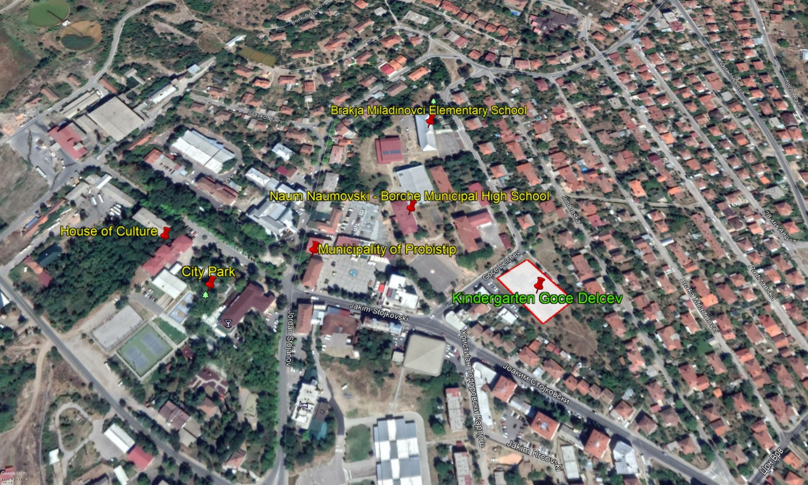
Figure 1 Micro location of the project area in Municipality of Probistip

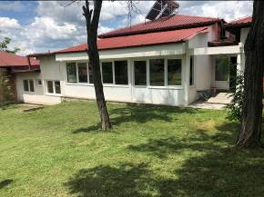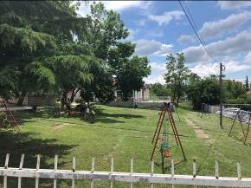
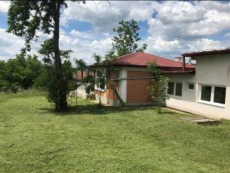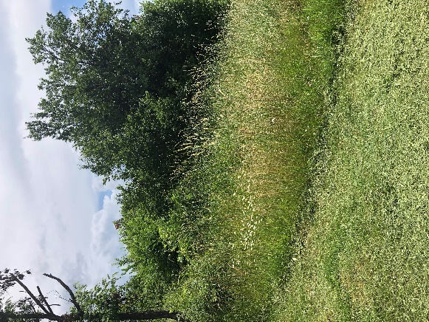
Figure 2 Current situation of the project location in Municipality of Probistip

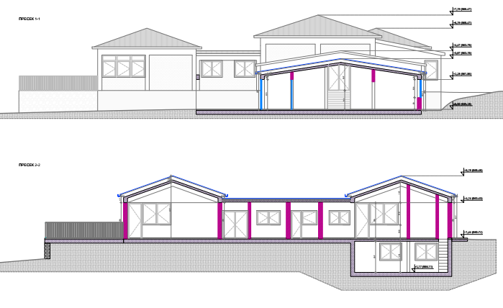
Figure 3 The exterior of the extended kindergarten

Toxic/hazardous materials include but not limited to fuels, motor/hydraulic oils, lubricants, toxic paints, etc.

